Spring Boot - Monitoring Microservice with Prometheus and Grafana



Monitoring our Spring Boot based microservices using Micro meter monitoring System.



Micrometer provides a registry which will help us to get the feed from JVM (related to JVM memory, Heap memory, and garbage collector, etc) and map those data metrics in a graphical way.

We will use here Prometheus and Grafana.





Using Prometheus we will get all the metric data over HTTP and in Grafana we will fetch those data which Prometheus stored in our Grafana server.

We are not going to install Prometheus and Grafana in our local machine. Instead we will use docker.

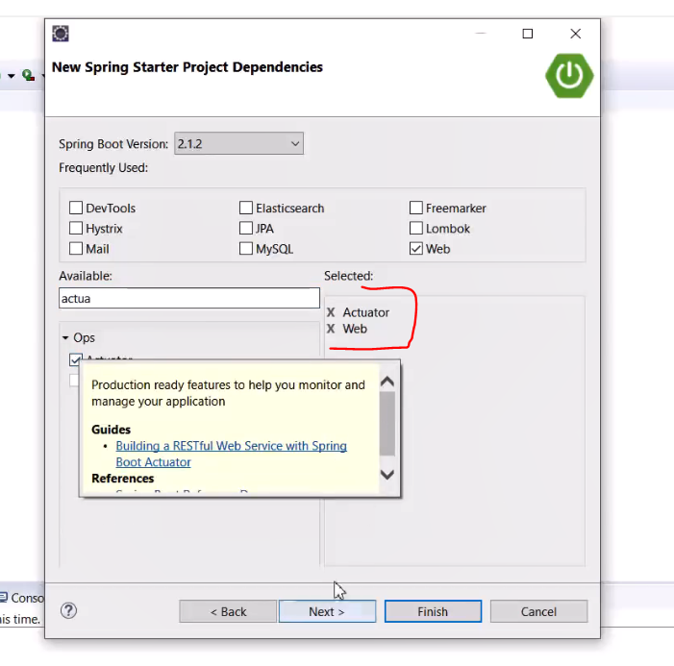

Rest dependencies will be added later.

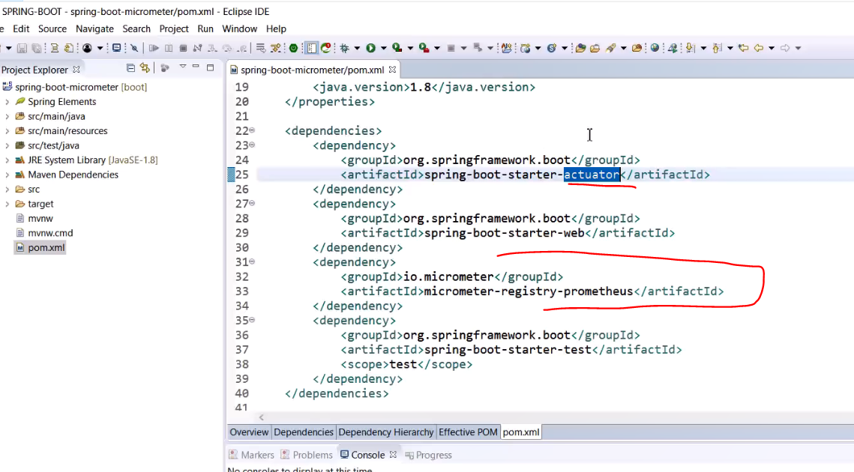

For spring boot 2.x, for actuator we need to manually enable the endpoint.

Manually enable the actuator endpoints:

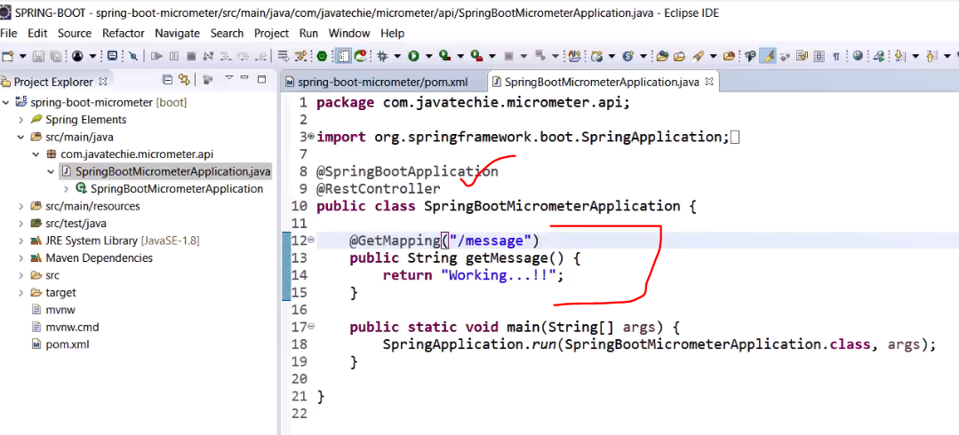

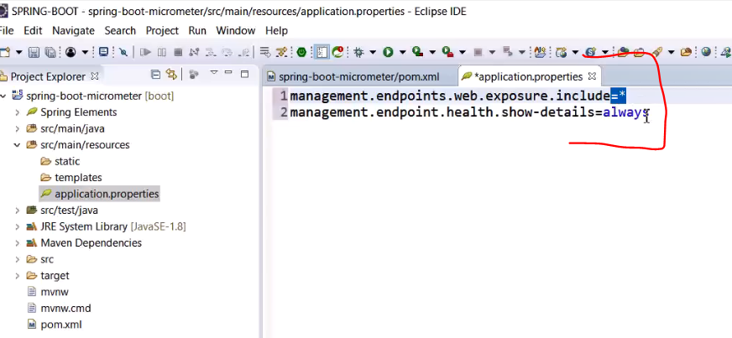

Now run the app, to check if Prometheus registry working properly or not:

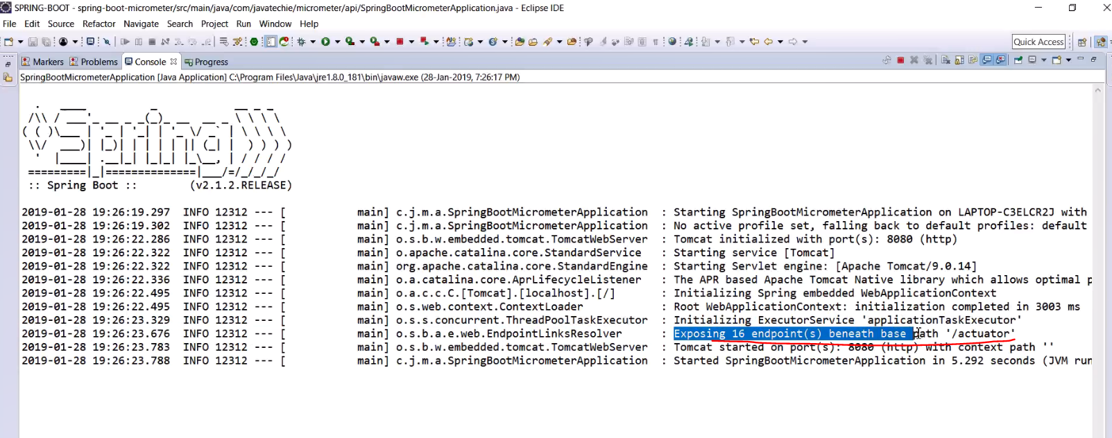

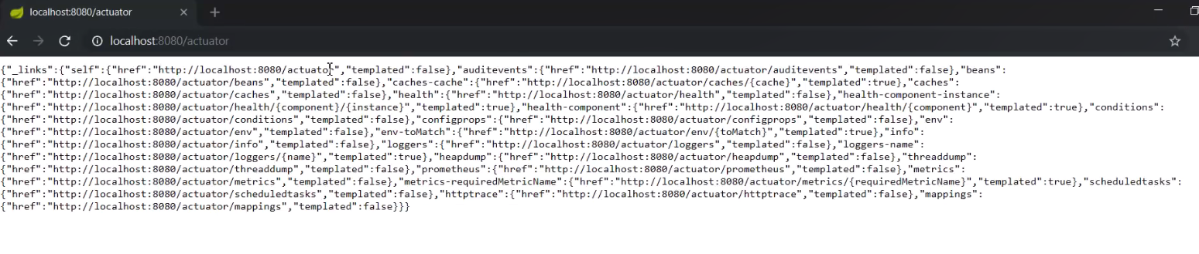

These are the endpoints enabled by the actuator dependency.

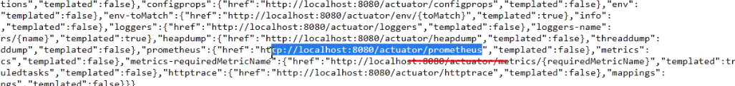

One of them is Prometheus.

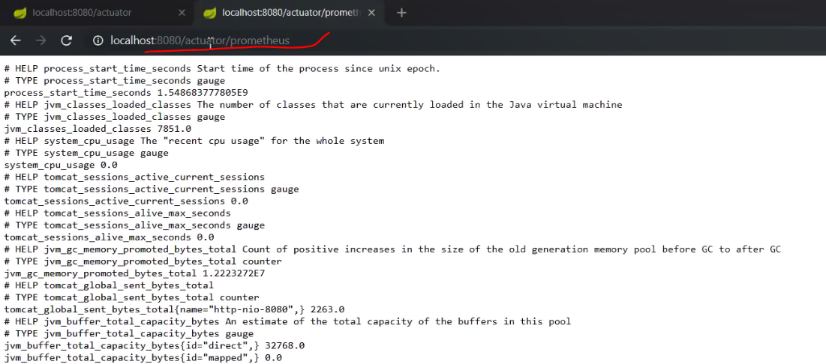

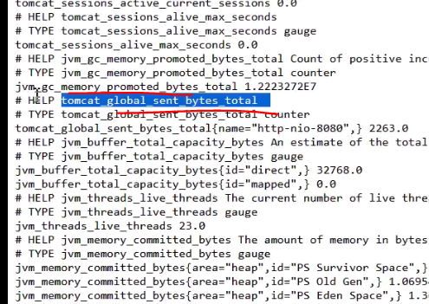

JVM related stuff are here.

We can represent these data in our Prometheus server. Here we will use docker for it.

From Docker Hub we will pull the Prometheus image and run it on our host operating system:

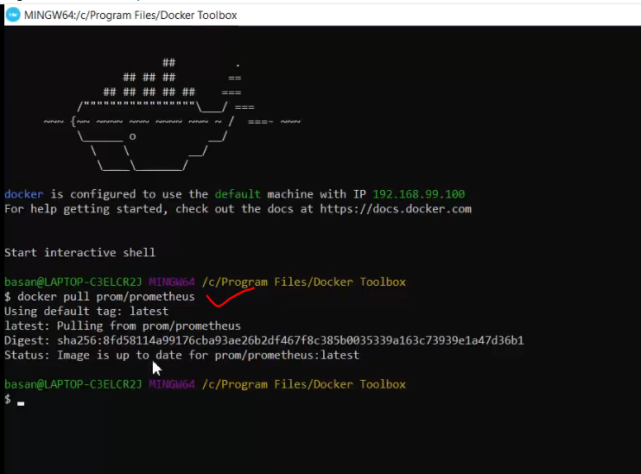

Now we have Prometheus server in our environment.

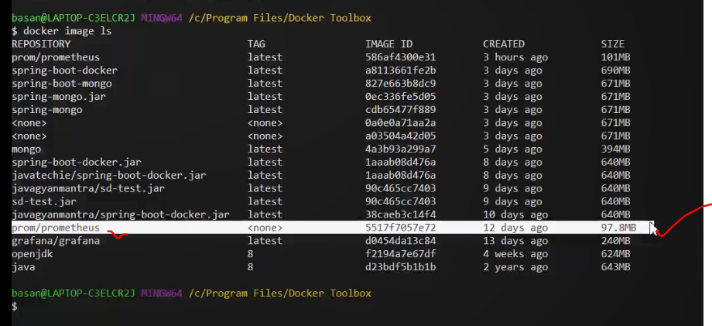

To work with this, we have to provide a YML configuration file to this Prometheus server.

Create a new file in STS:

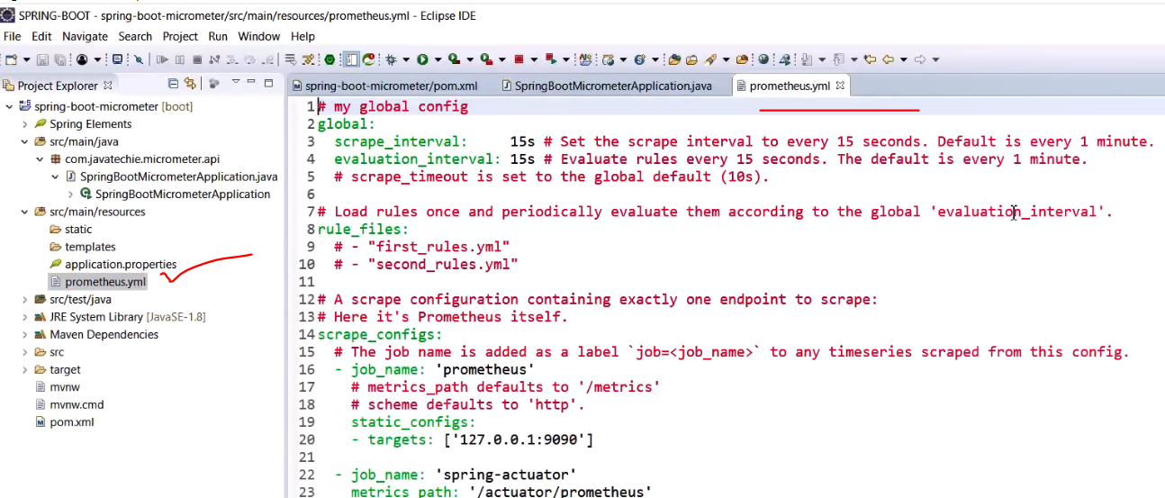

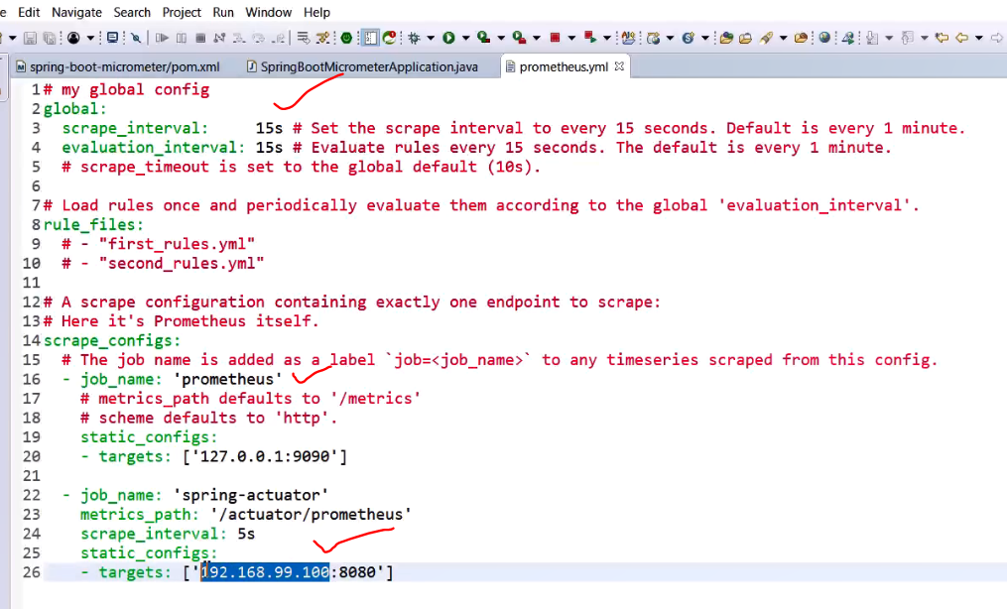

In target, we need to provide our IP as mentioned in our docker terminal:

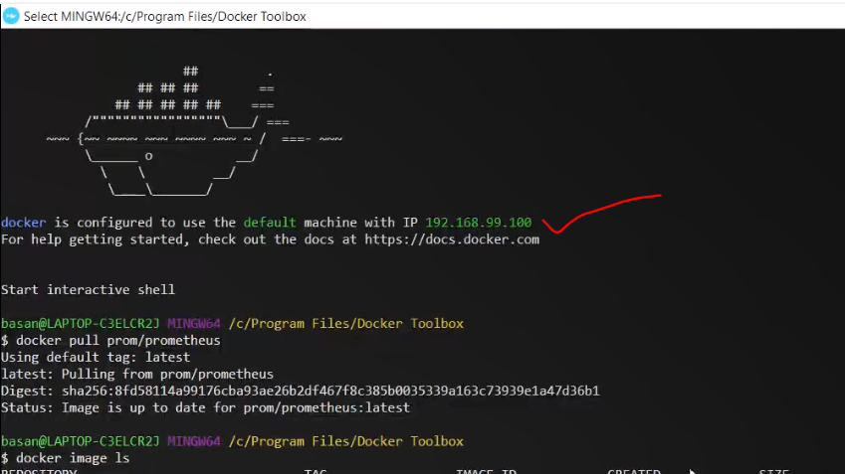

Now using docker, we need to run our Prometheus server:

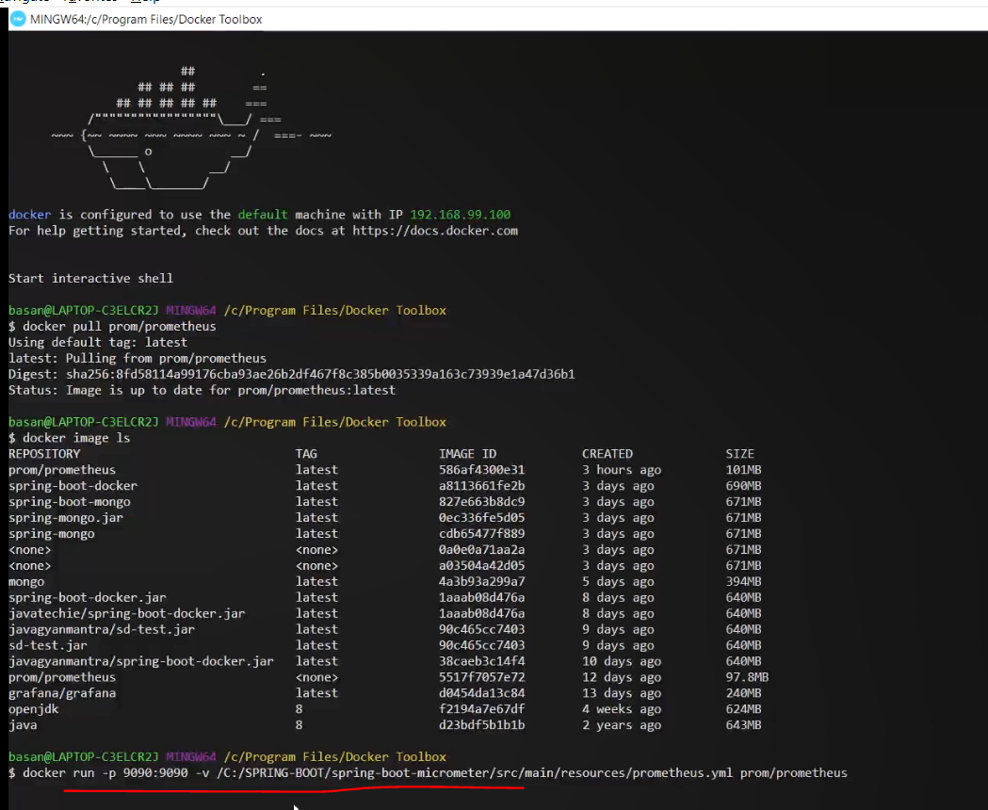

Command:

Docker run -p <port> -v <Prometheus YML file path> <name of Prometheus Image>

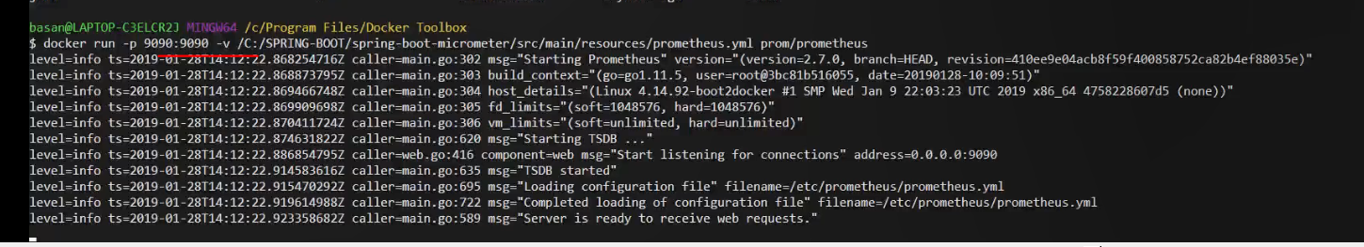

Started on port 9090

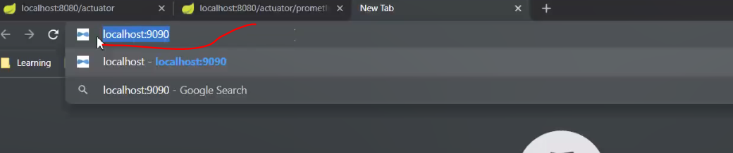

With localhost we cannot run any docker image or docker instance in our host operating system.

Instead we have to use the IP address.

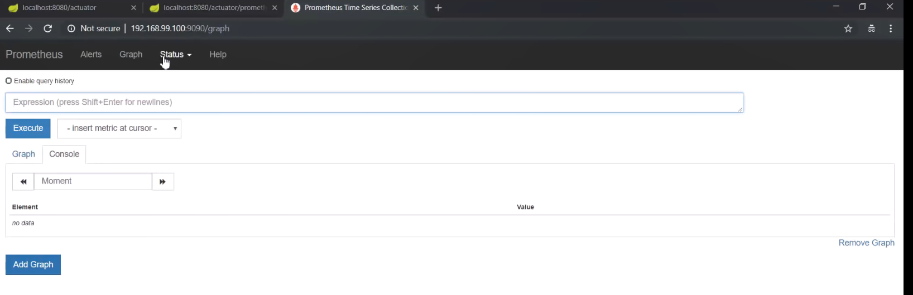

This is the dashboard of Prometheus.

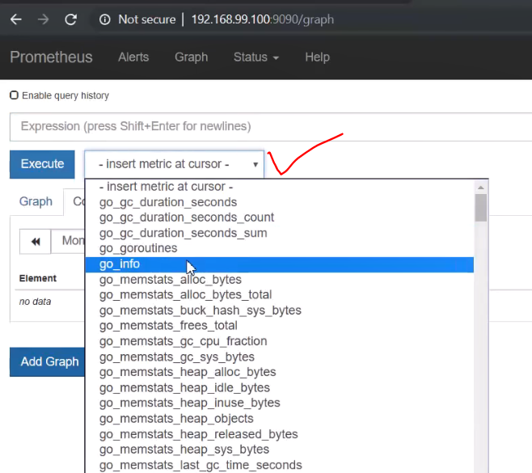

Choose any metrics from here.

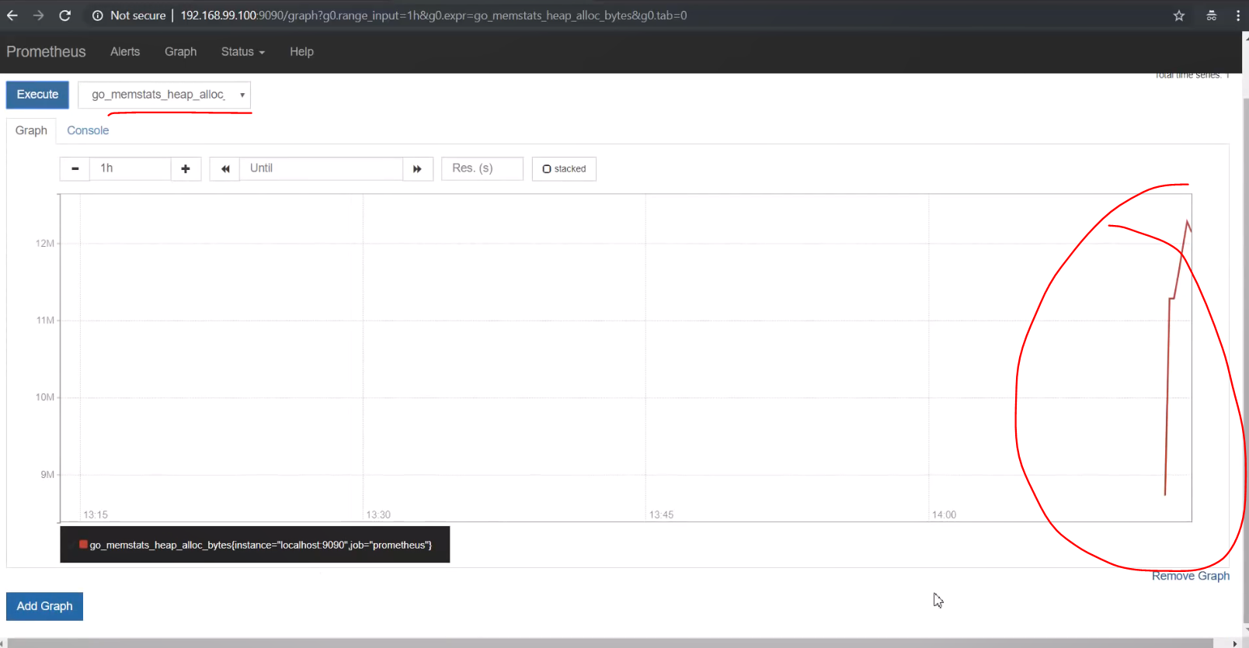

We can observe the graph from here. These are Prometheus metrics.

Now we will run the Grafana, and from Prometheus metrics we will fetch the data and we will represent in Grafana.

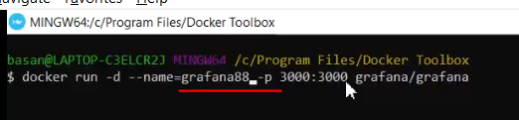

Command:

Docker run -d –name=<name of Grafana, any name here> <port> < Grafana Image name(as available in DockerHub)>

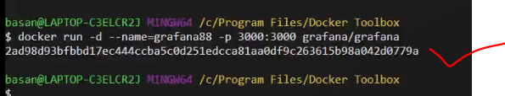

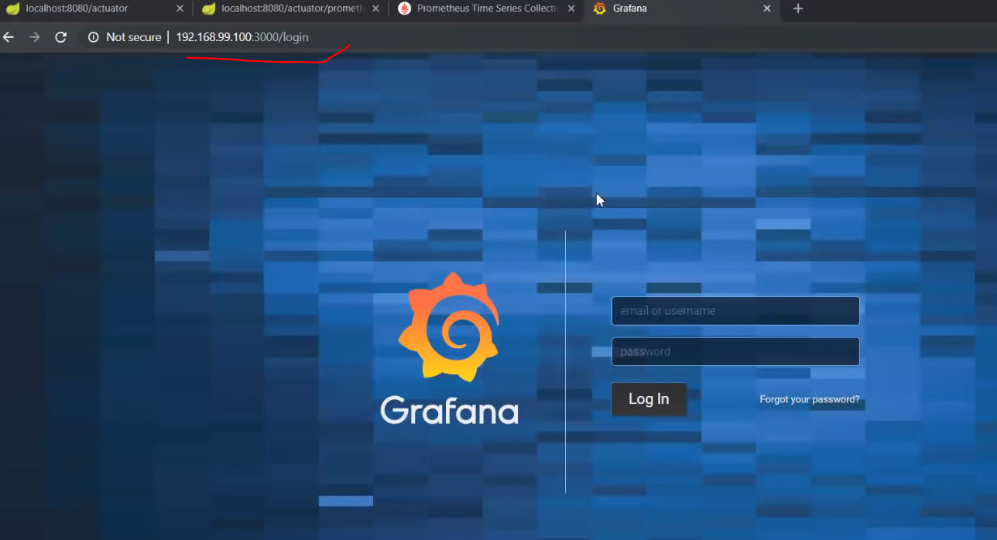

This is the Grafana Homepage.

Default: admin/admin

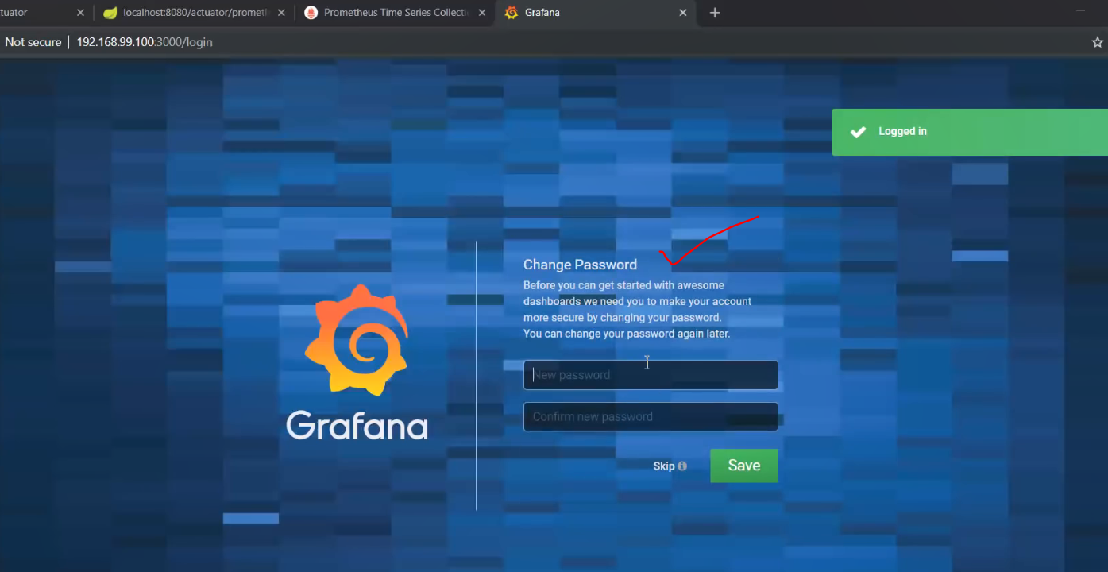

Change or skip it.

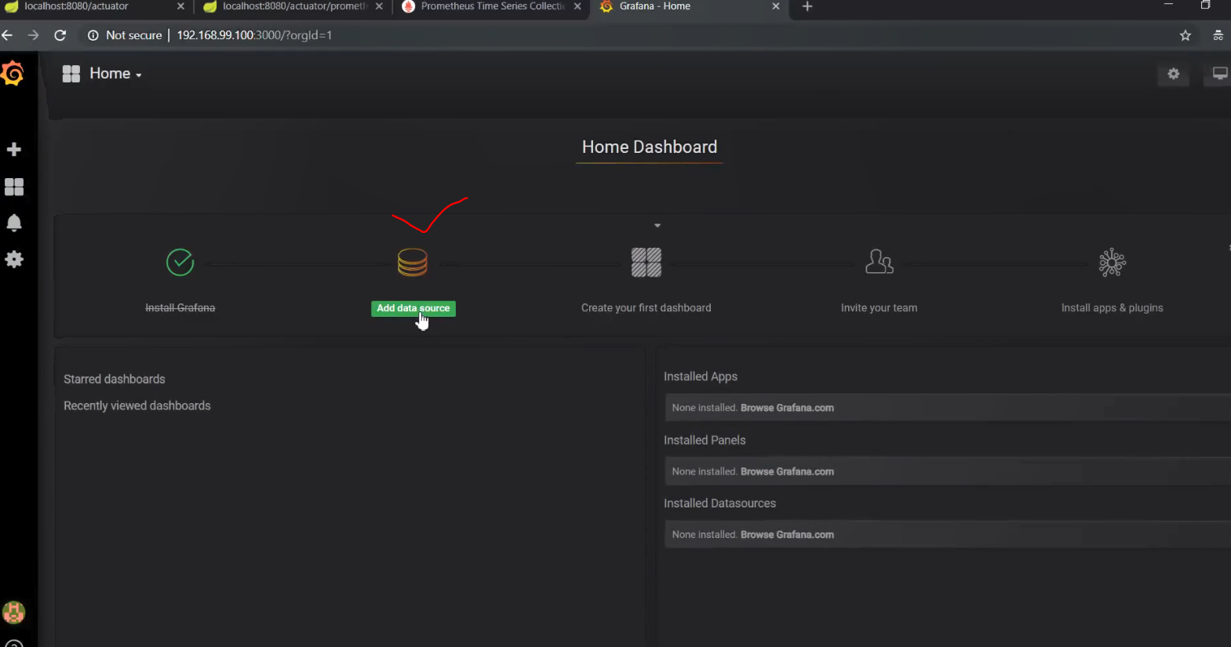

Add the data source.

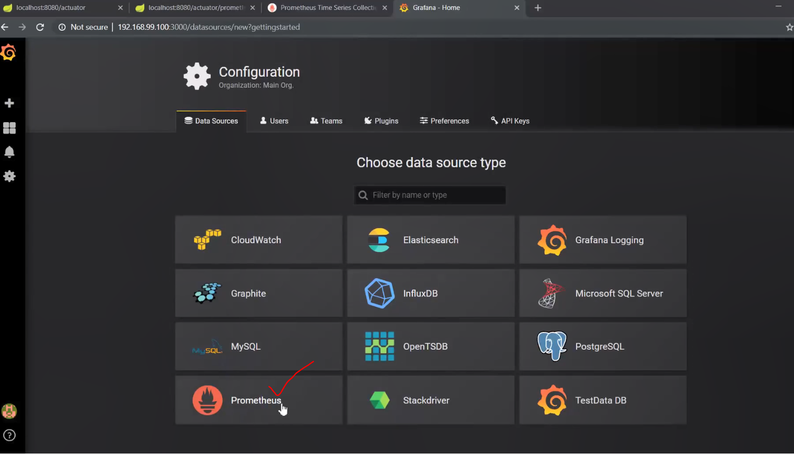

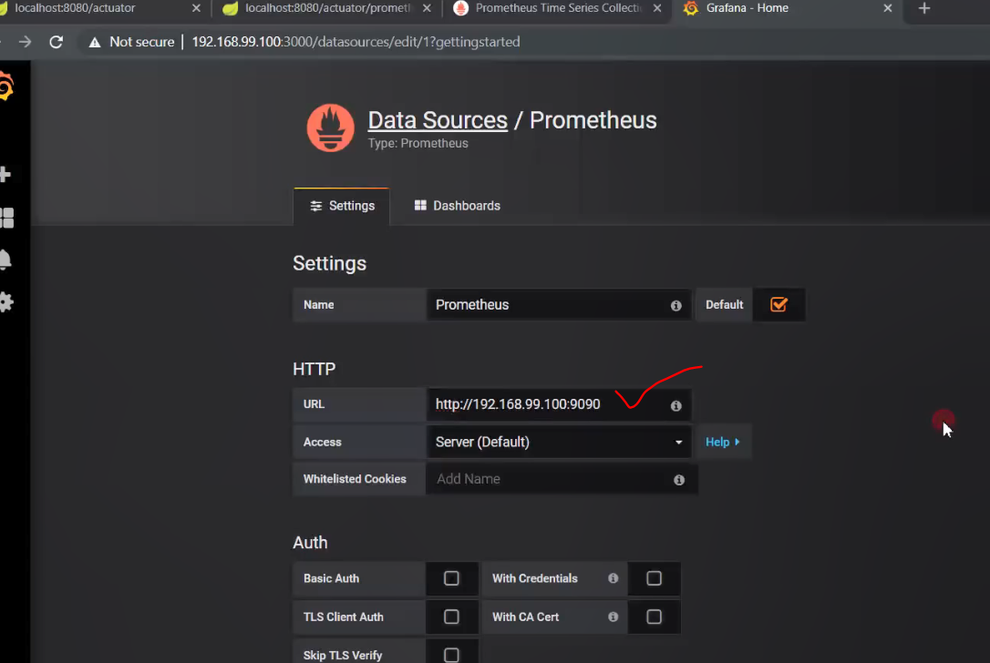

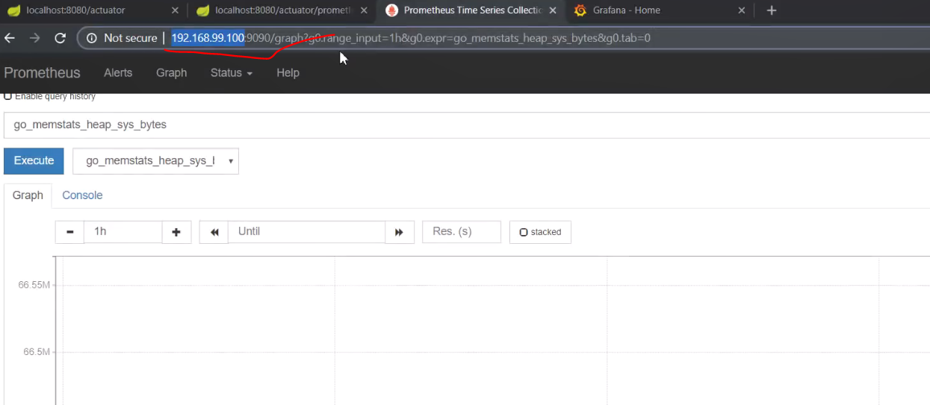

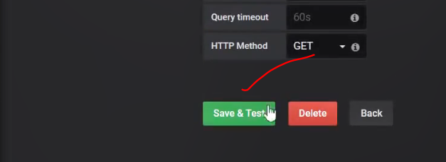

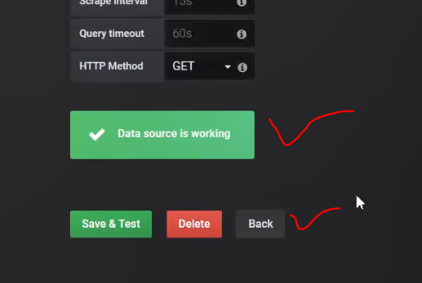

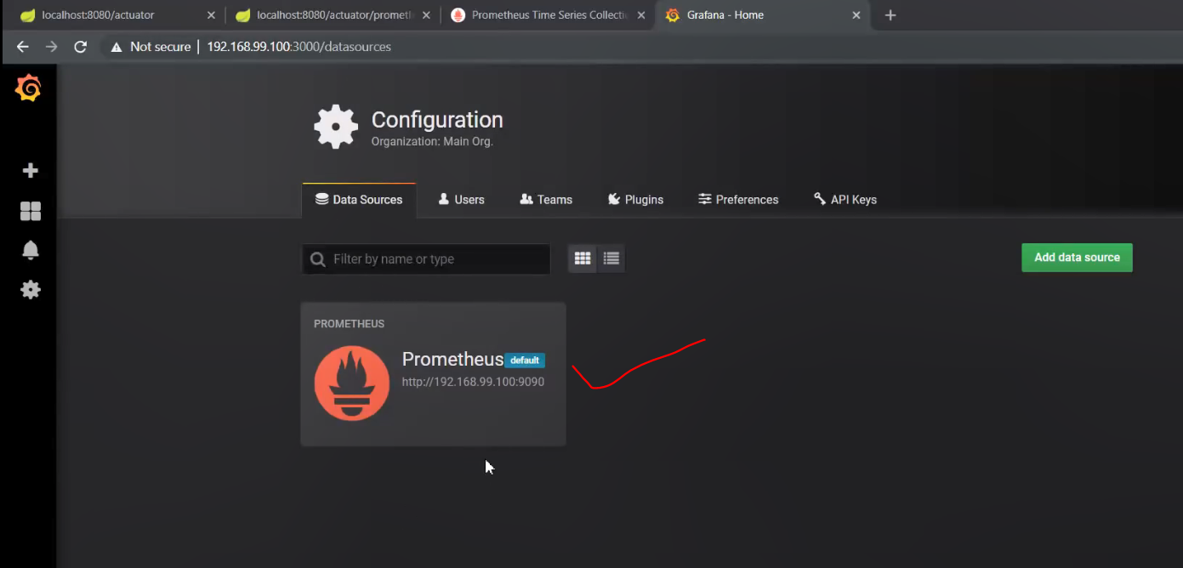

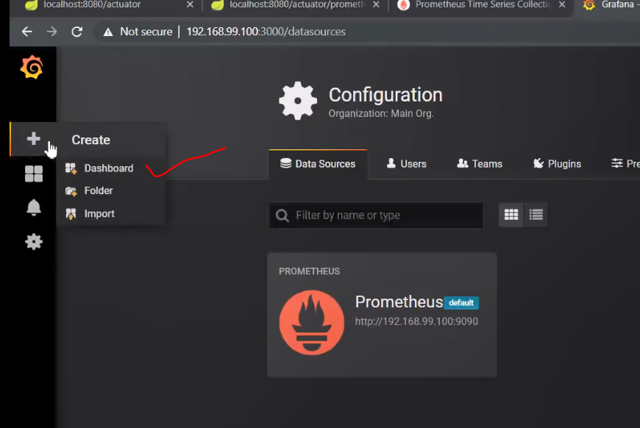

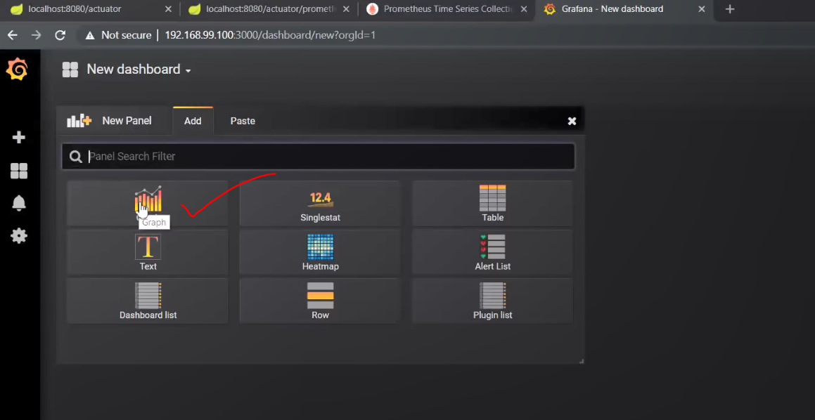

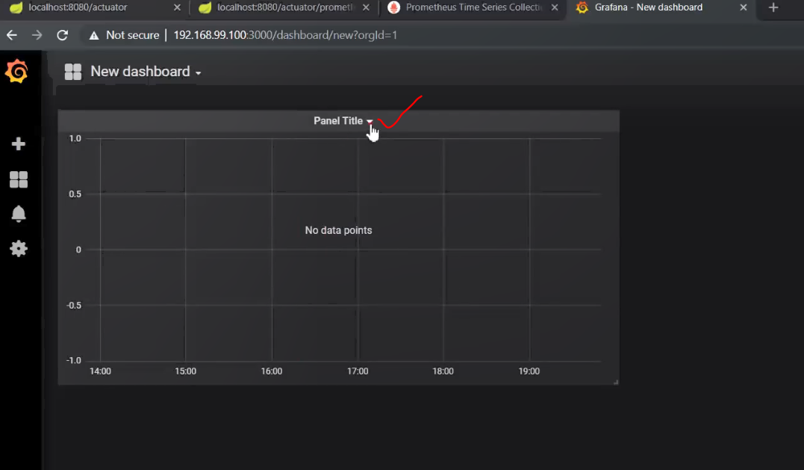

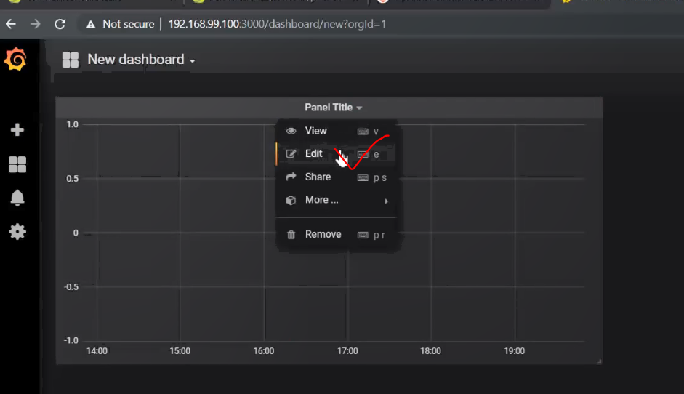

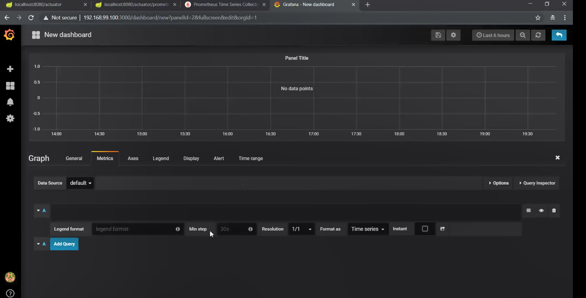

This is the default dashboard.

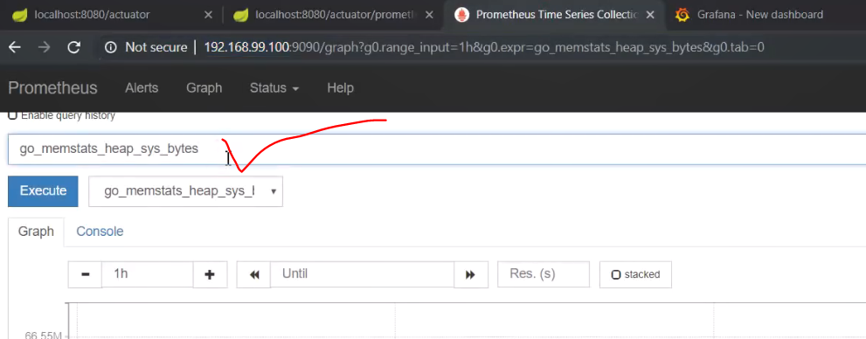

Get the metrics:

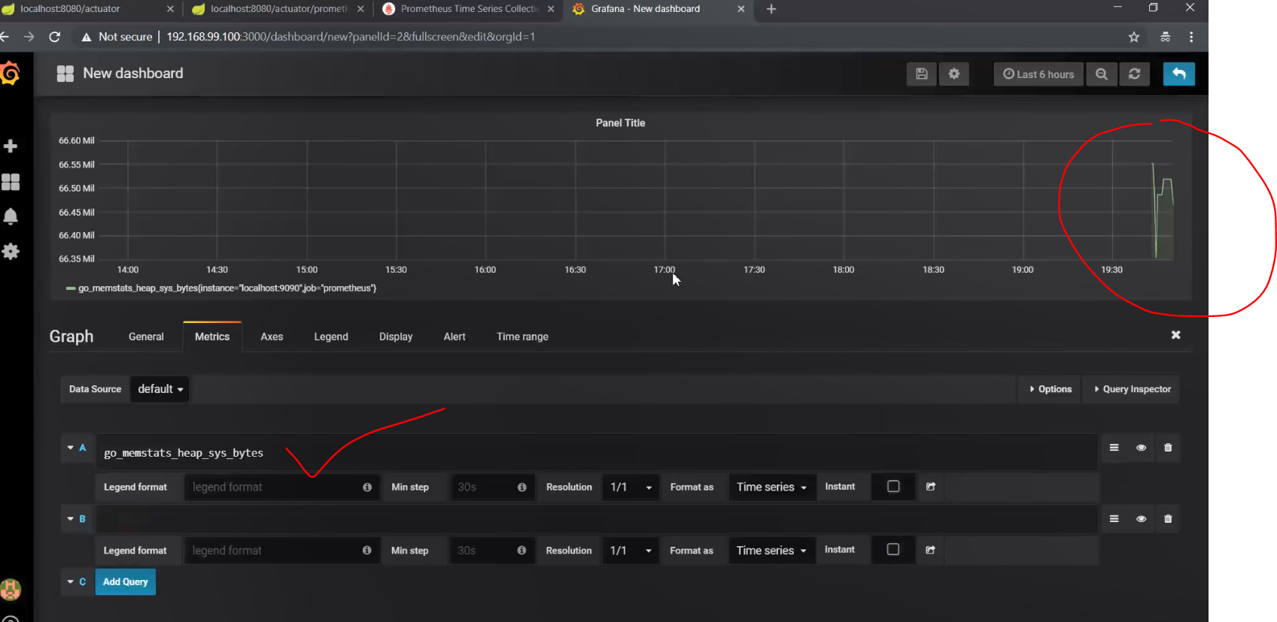

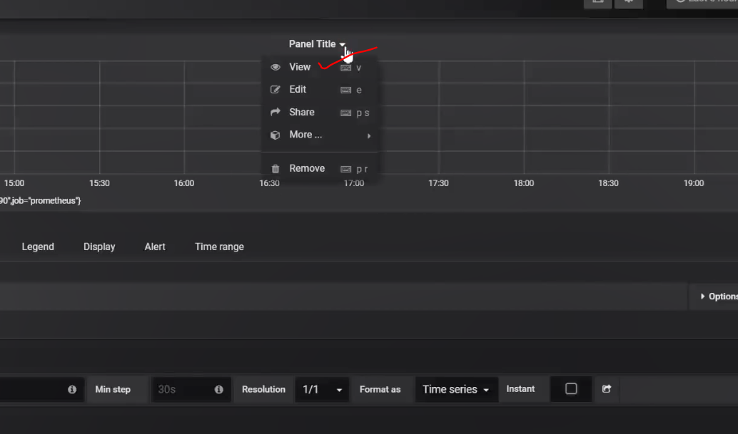

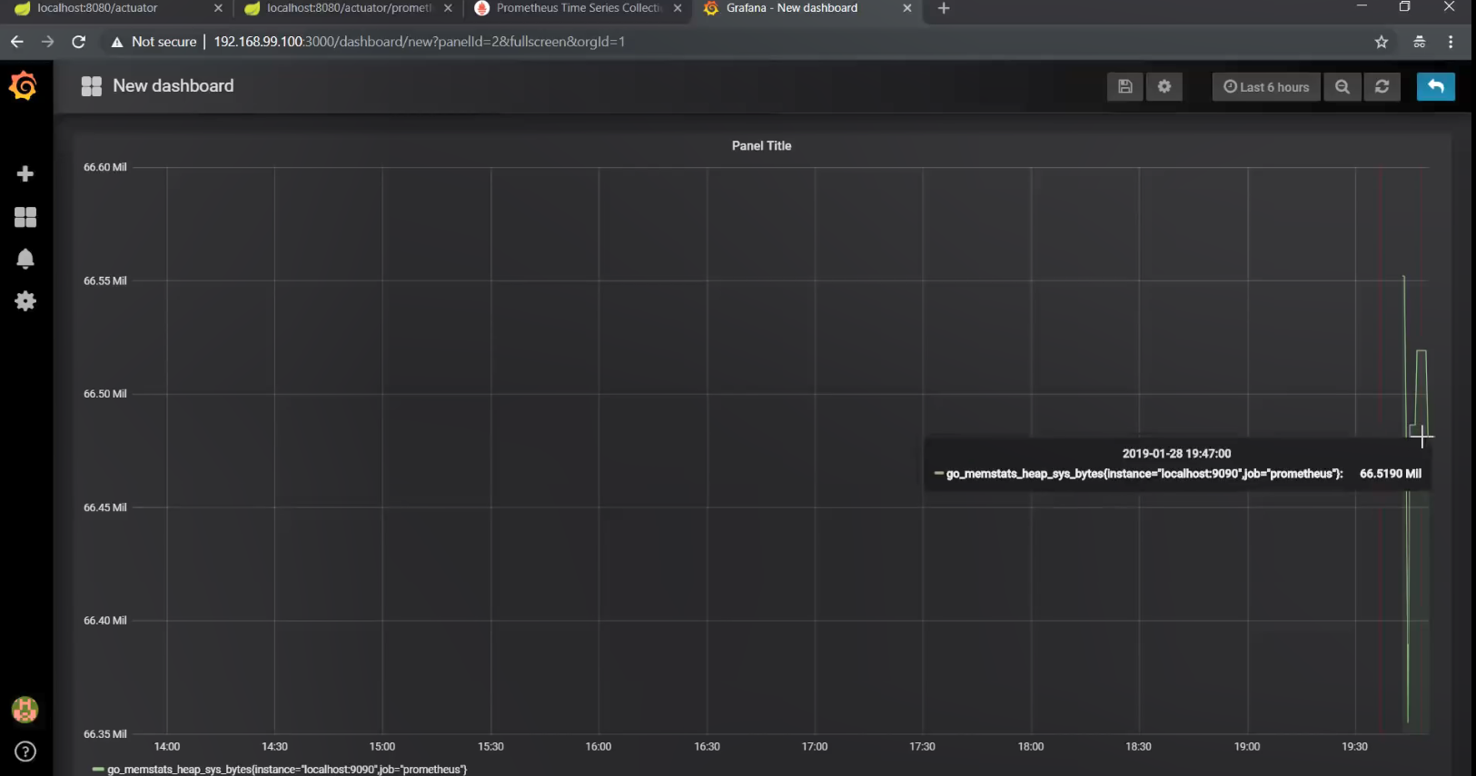

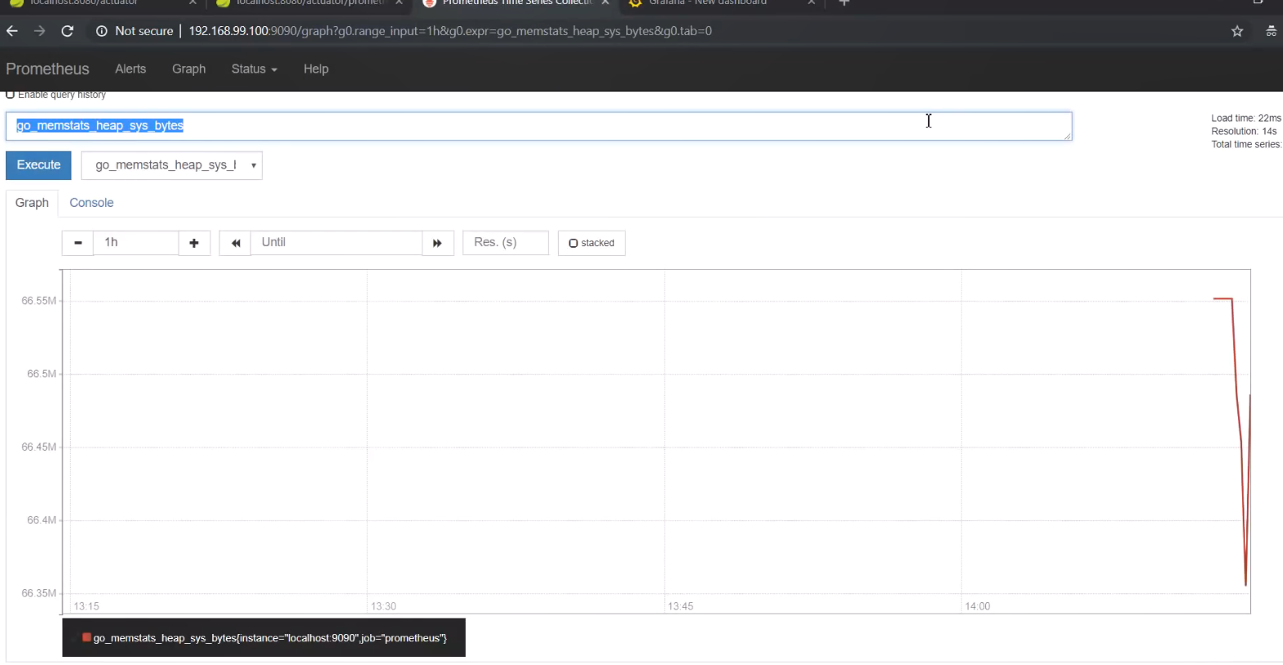

The same graph can be viewed in Prometheus as well!

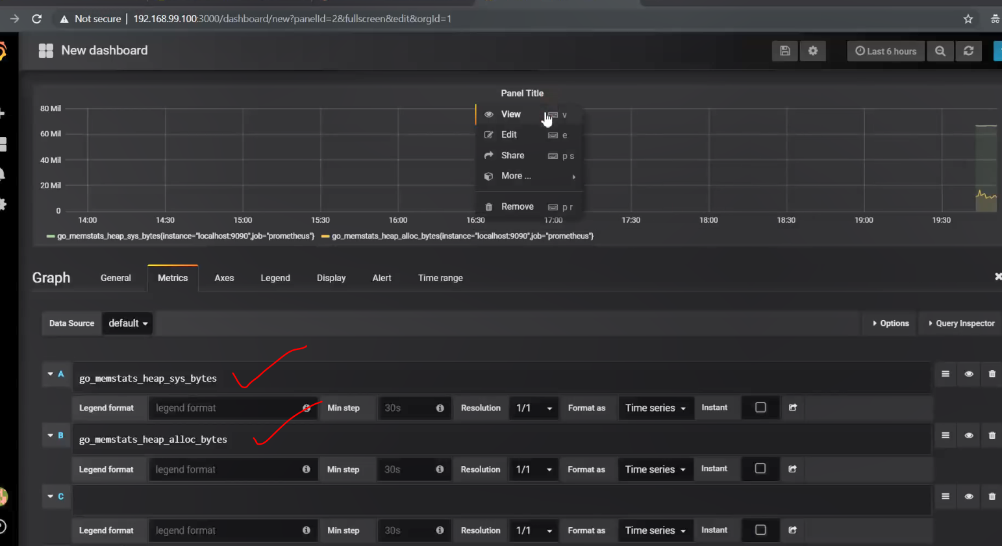

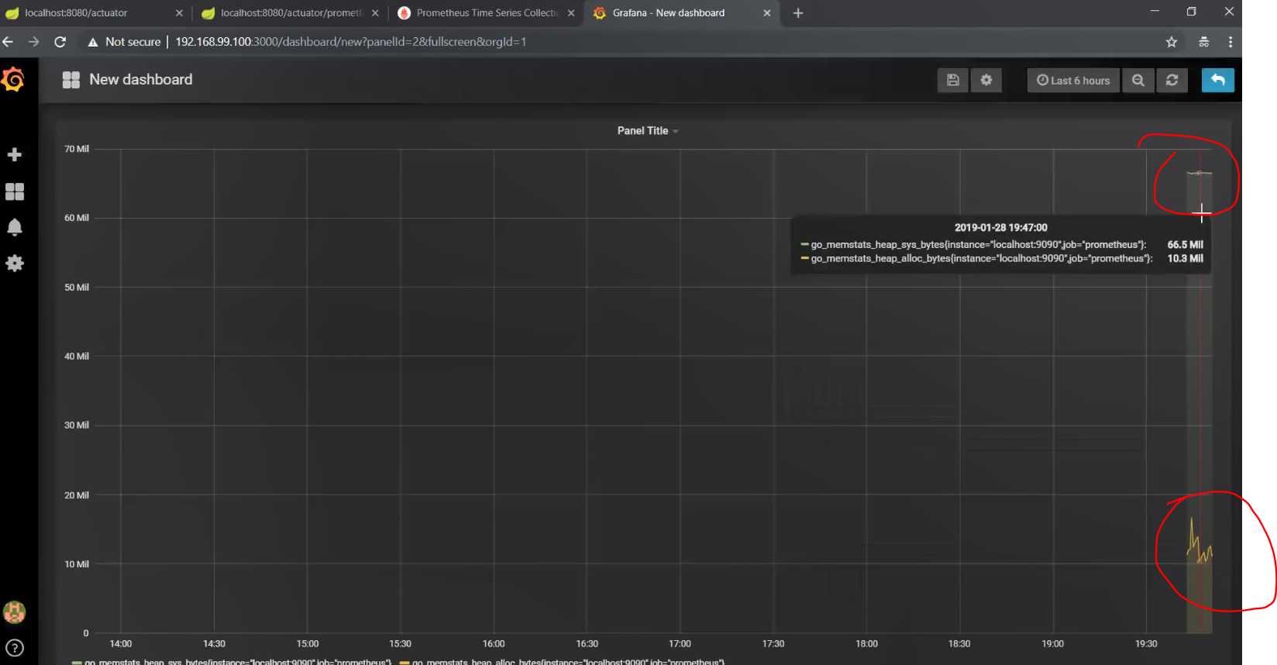

Done!

asdasdsad